GitHub Account Report

Step 1:

I already have a github account created in my previous semester for CS590VC course. So I signup using my username and password.

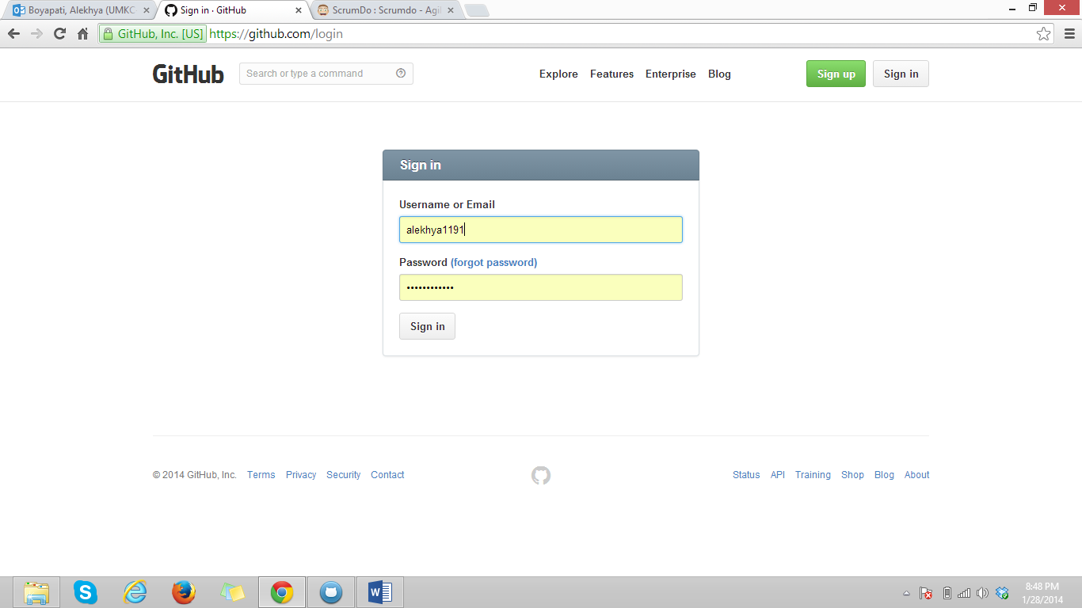

Step 2:

At present I have no repositories.

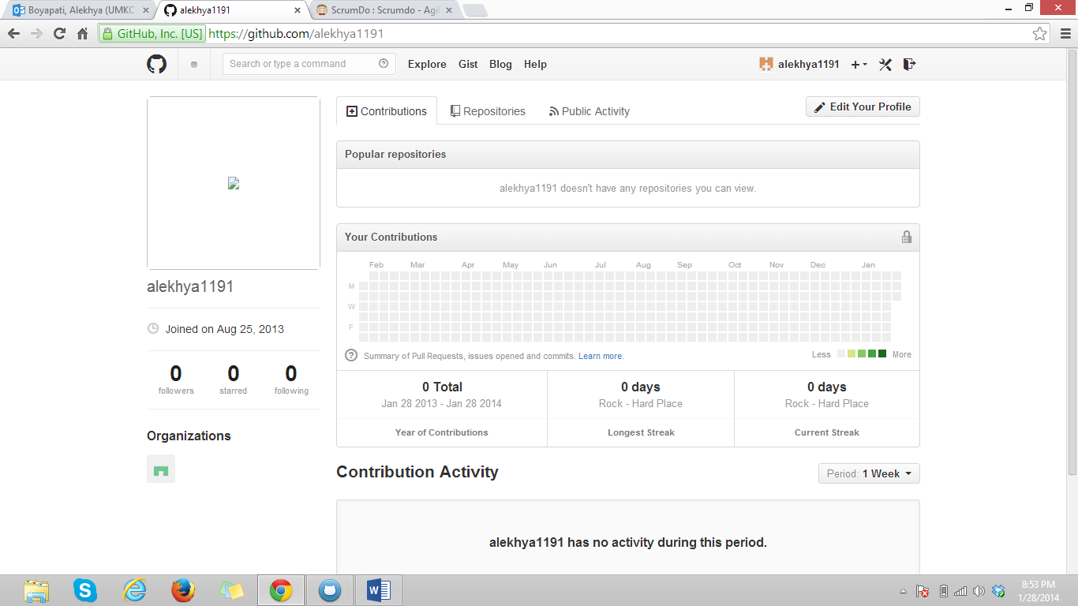

Step 3:

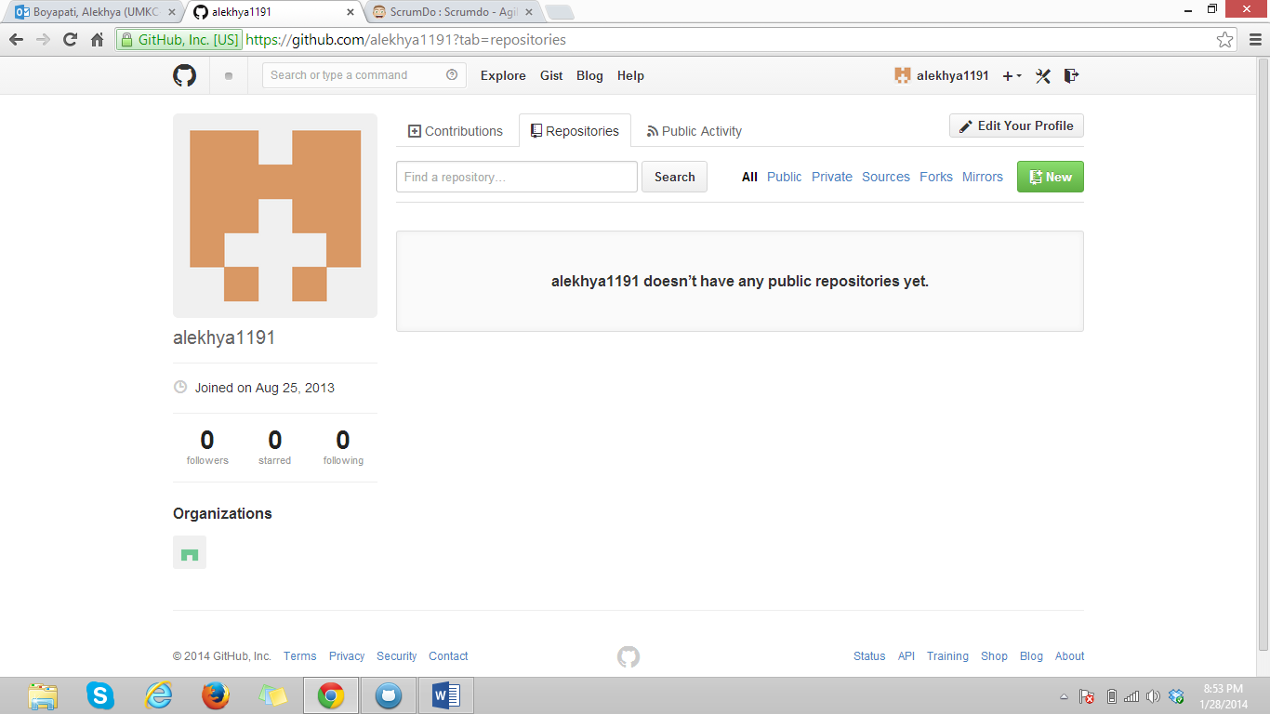

Step 4:

I have created a new repository titled ‘ AdvancedSoftwareEngineering’.

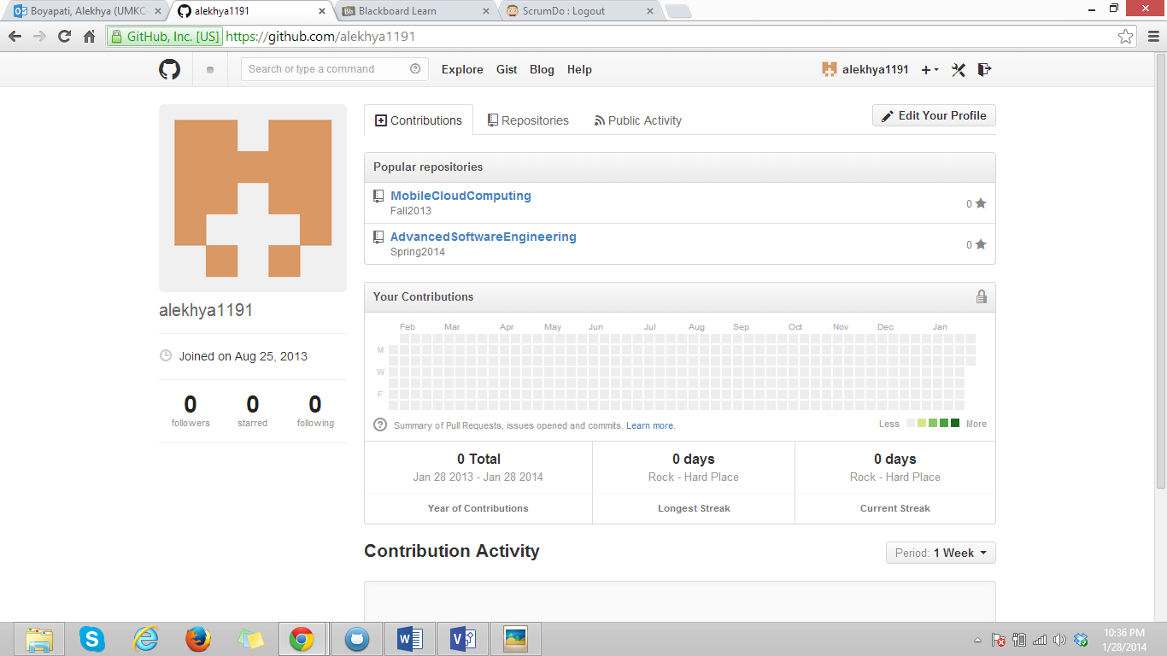

ScrumDo Account Report

Step 1:

As I have already created my ScrumDo account in previous semester for MCC course. So I logged in using my username and password.

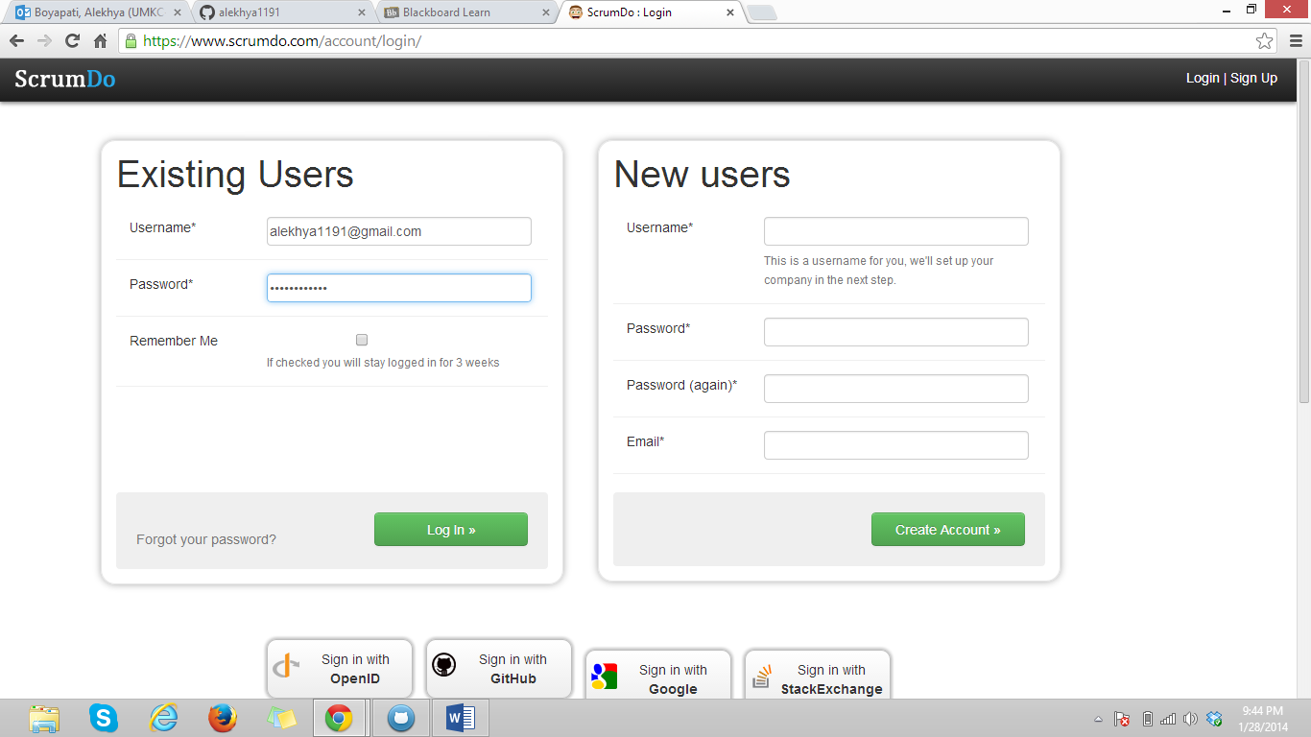

Step 2:

It has shown me the previous organizations, I created a new organization for Advanced Software Engineering course.

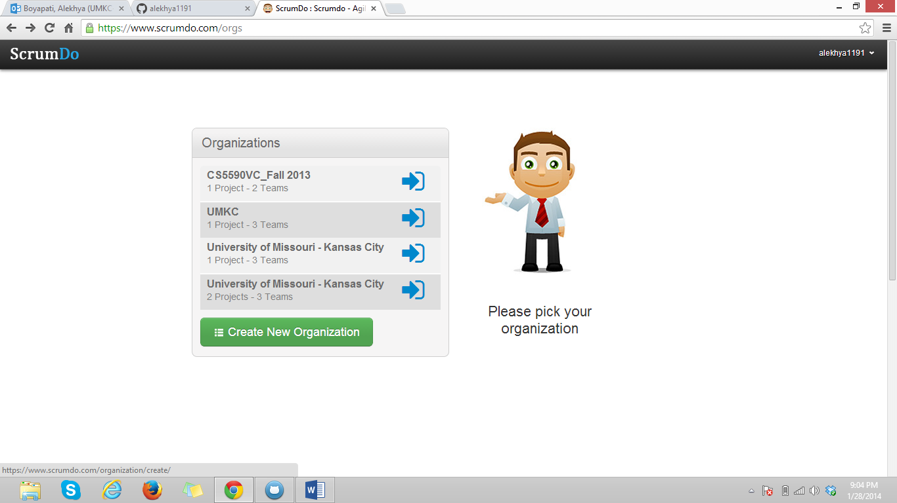

Step 3:

The name of name organization is ‘AdvancedSoftwareEngineering’.

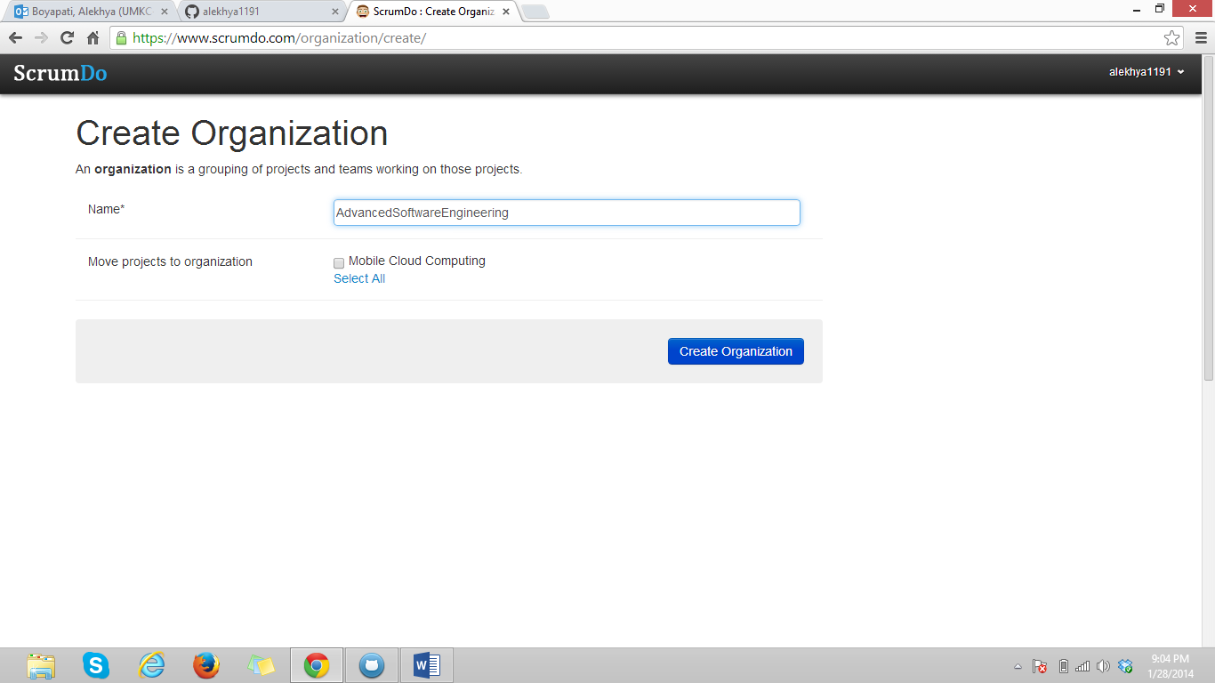

Step 4:

This is the view of my new organization.

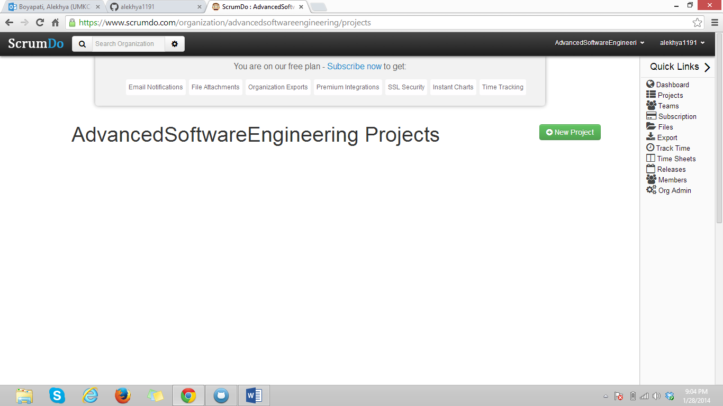

Step 5:

I have to create a story before I do anything. At present I have 0 stories which is shown in the summary

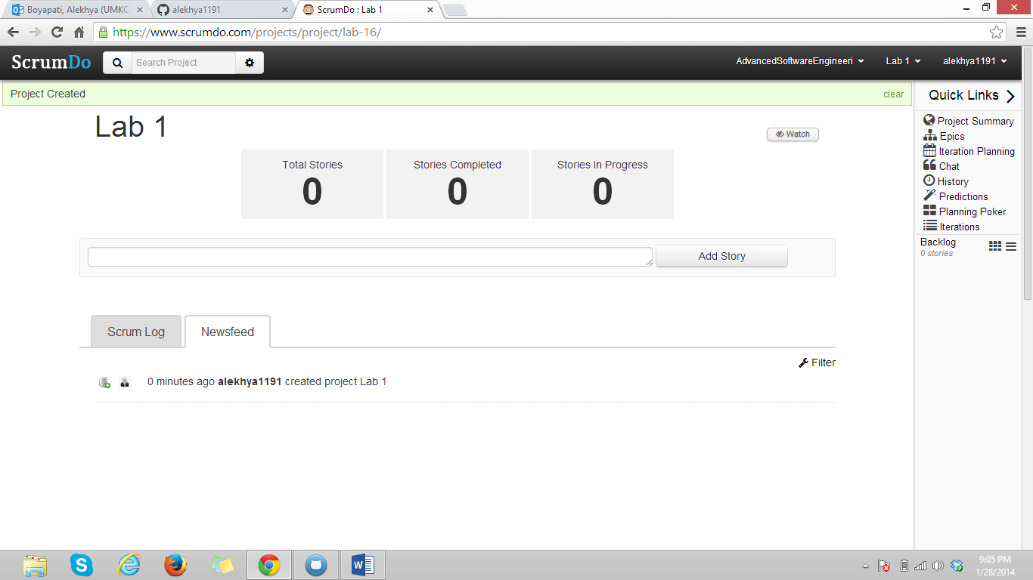

Step 6:

I created my first story in Lab 1.

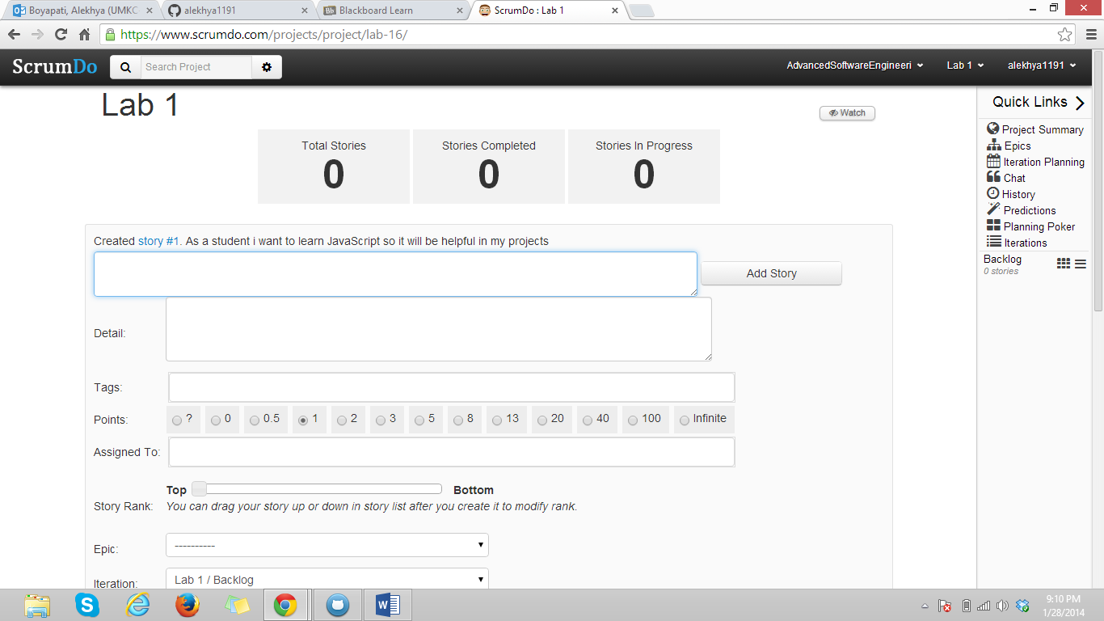

Step 7:

Now totally I have 3 stories, which are all in Todo state.

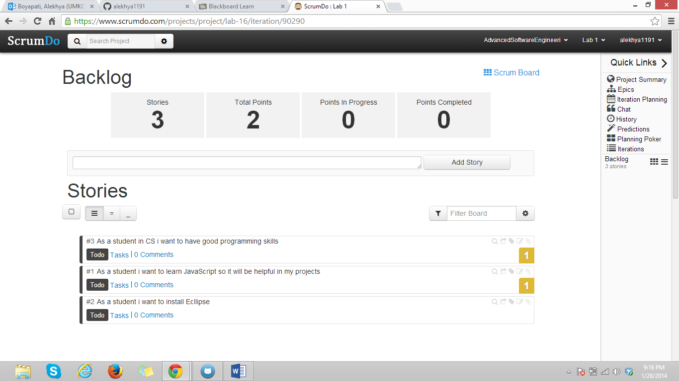

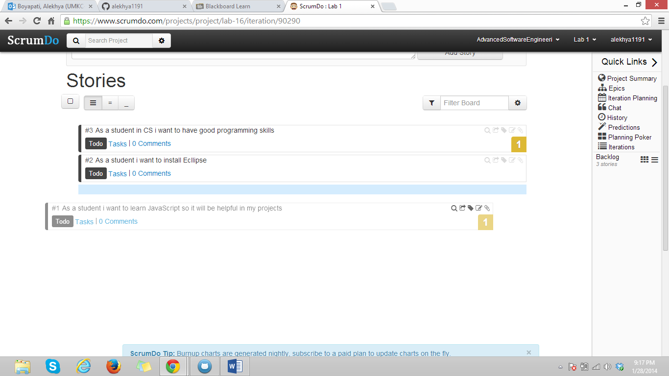

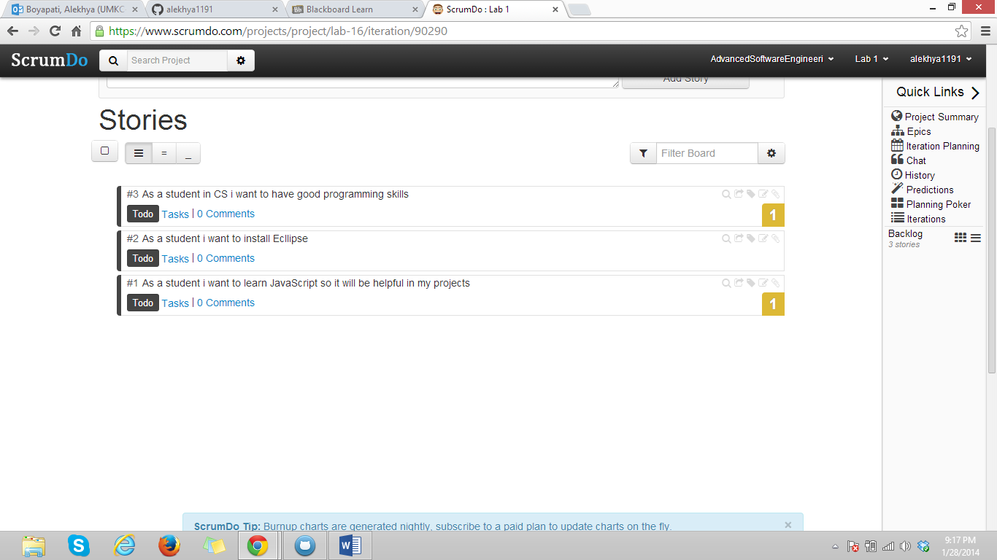

Step 8:

Creation of iteration.

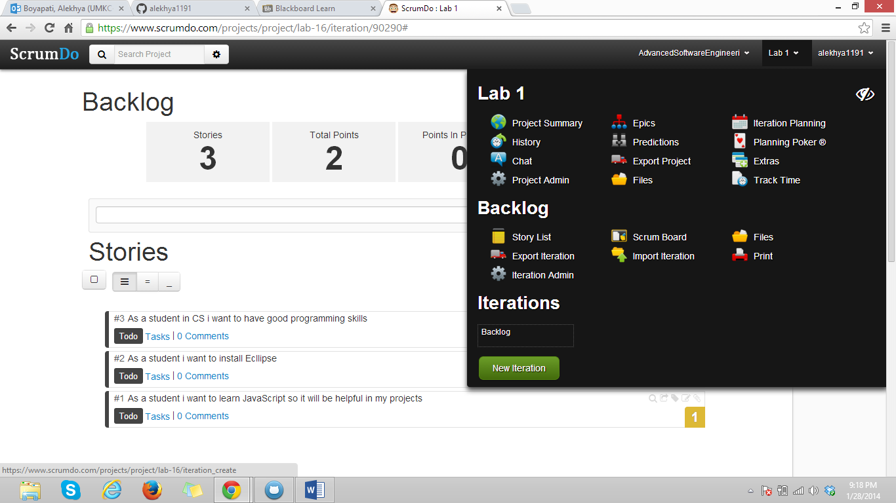

Step 9:

I created iteration#1 and its start and end dates are shown.

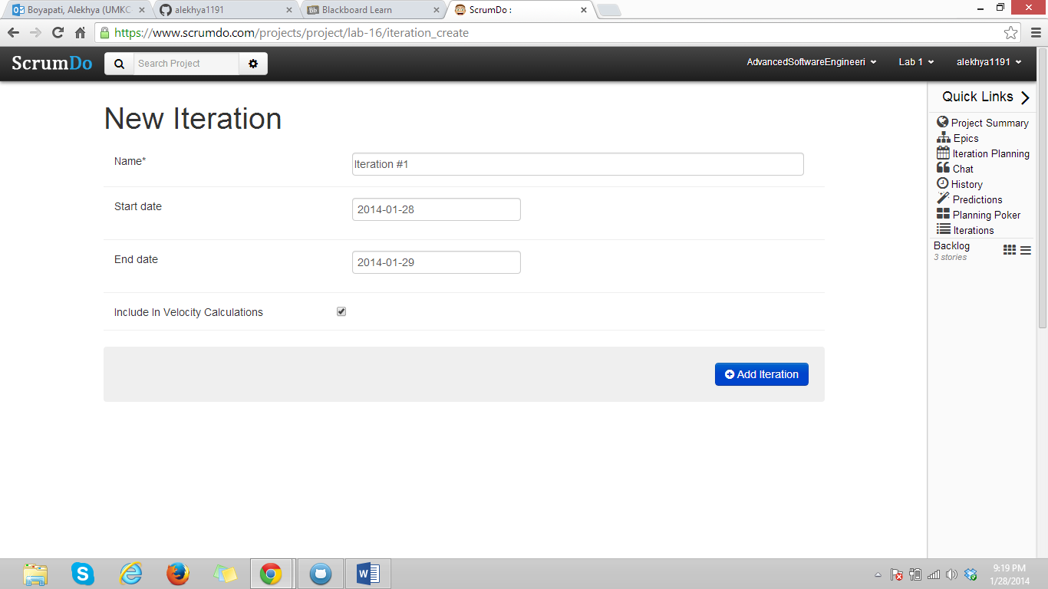

Step 10:

Total I created 4 iterations which are shown under iterations.

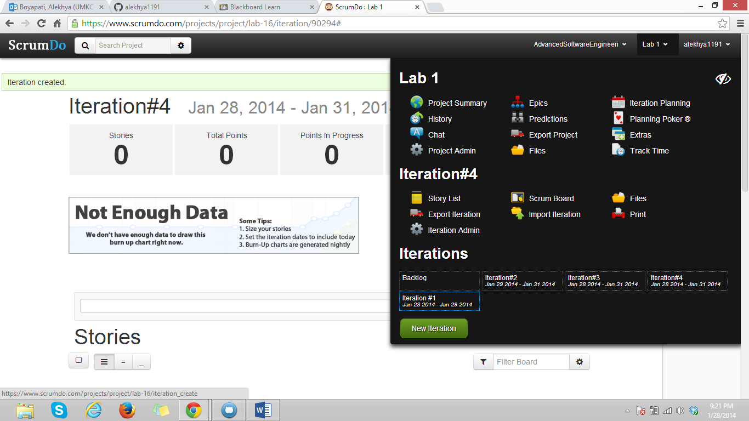

Step 11:

Iteration creation.

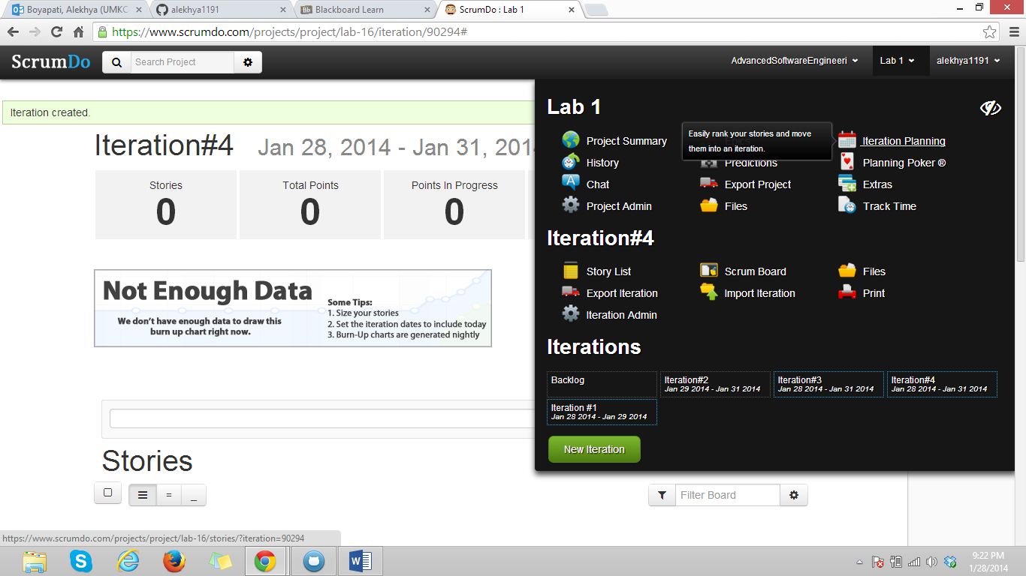

Step 12:

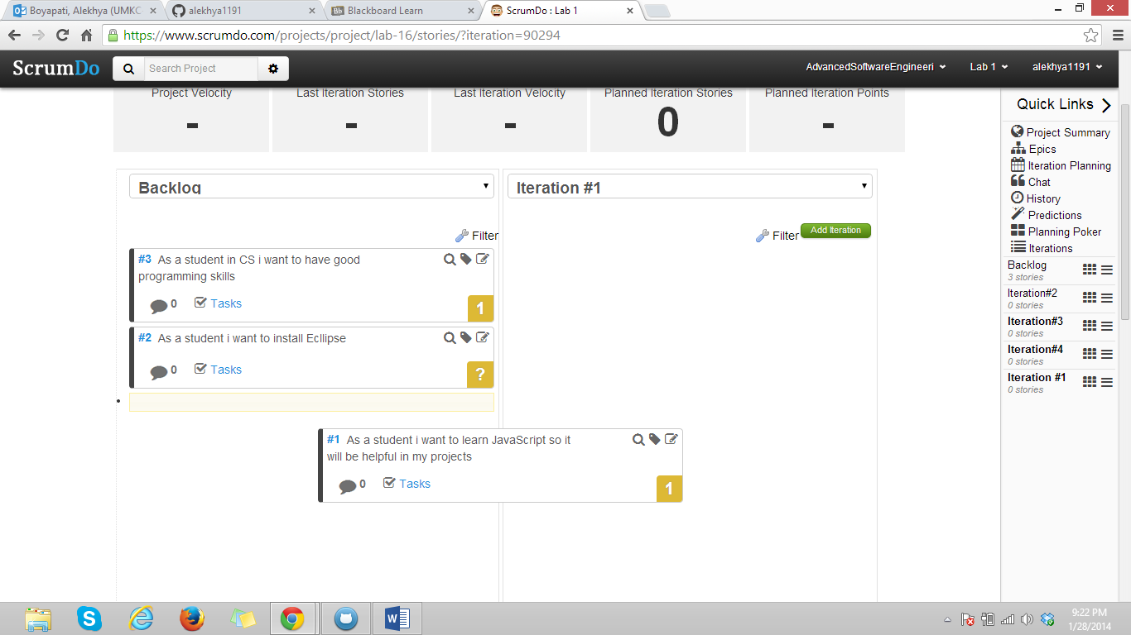

Step 13:

Epic story creation.

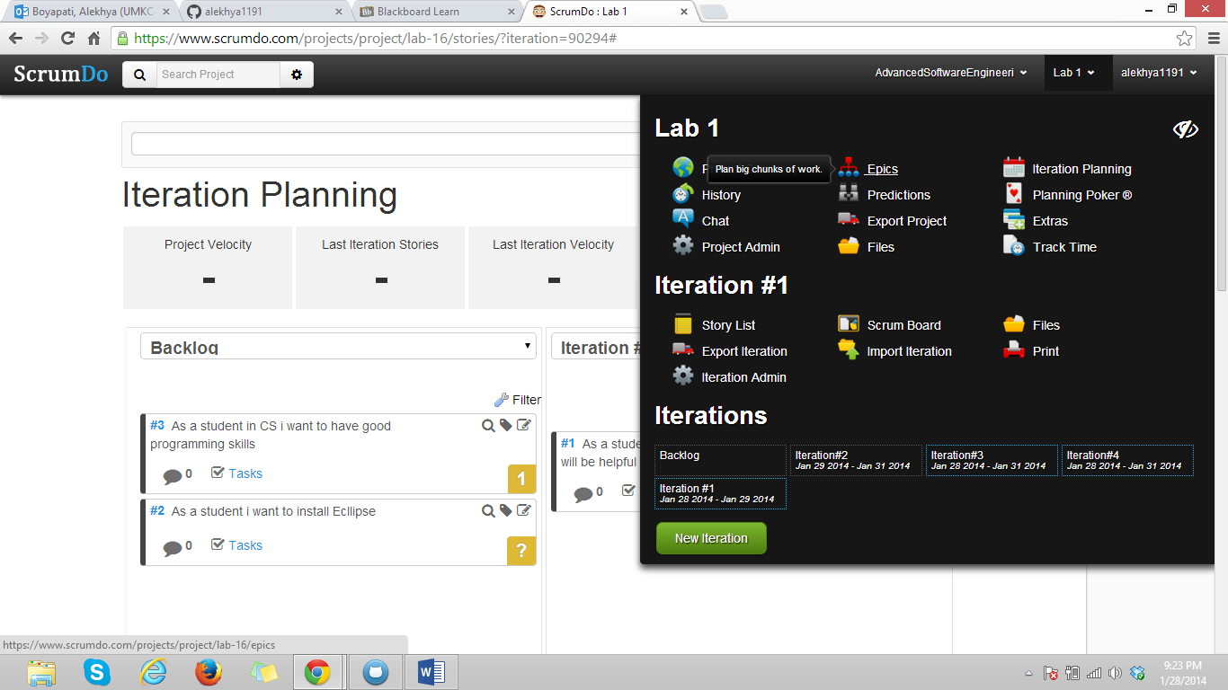

Step 14:

Creation sub-epics and new story for that epics.

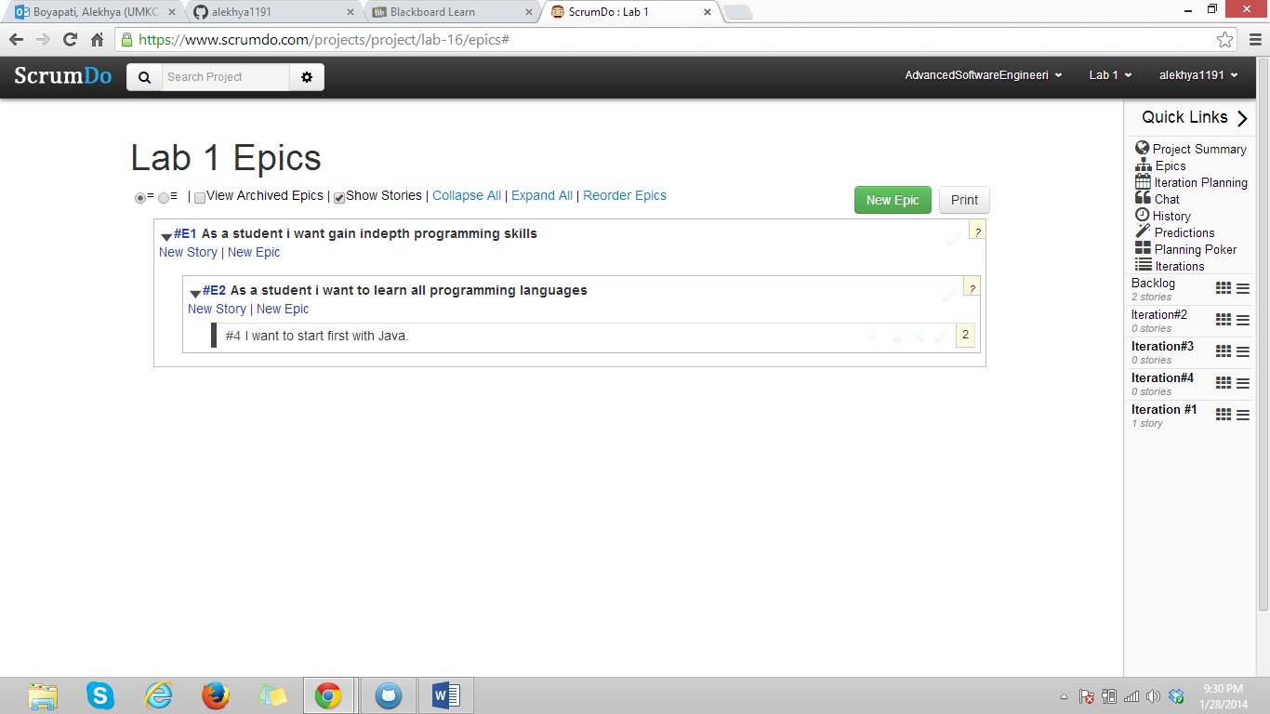

Step 15:

Scrum Board

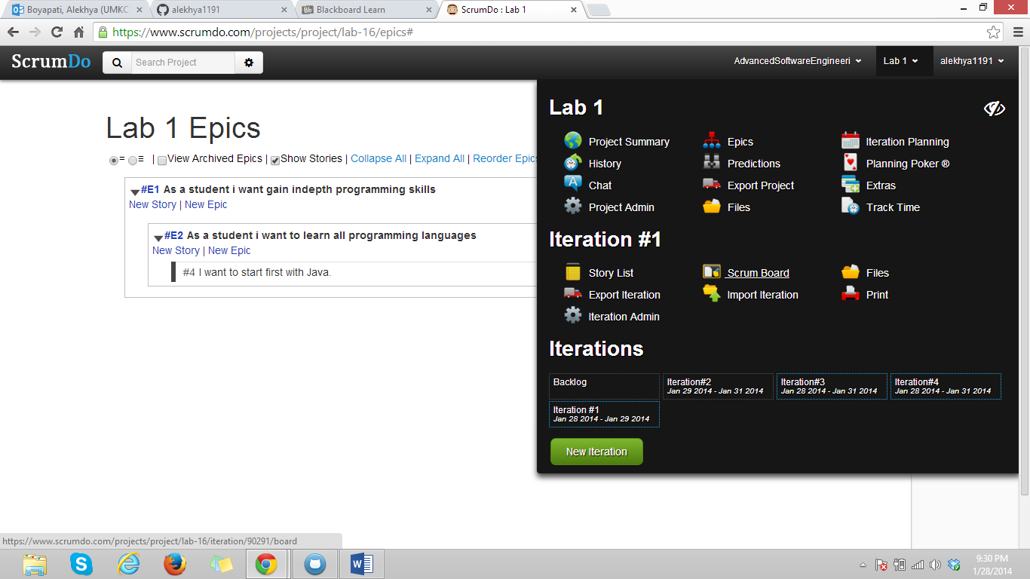

Step 16:

Stories in Scrum Board in Todo state.

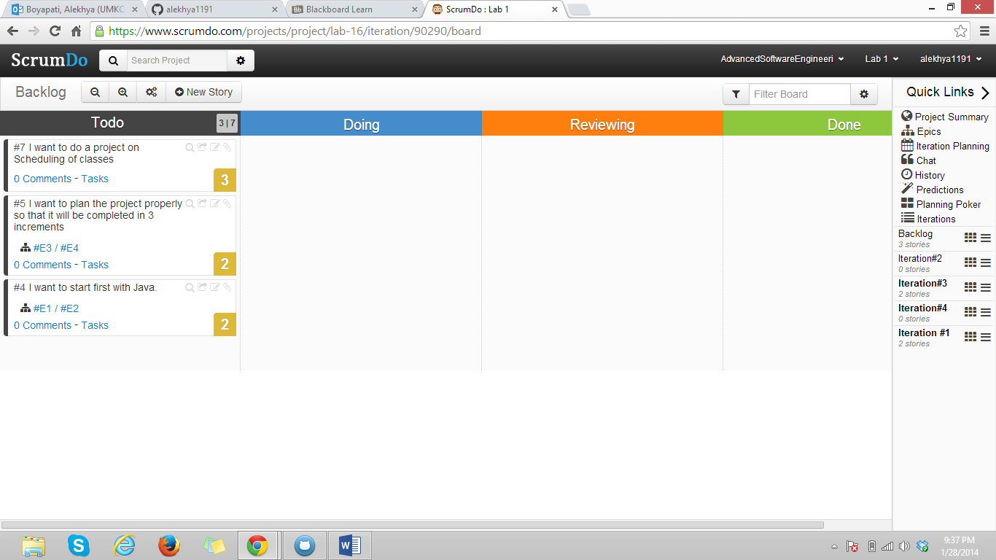

Step 17:

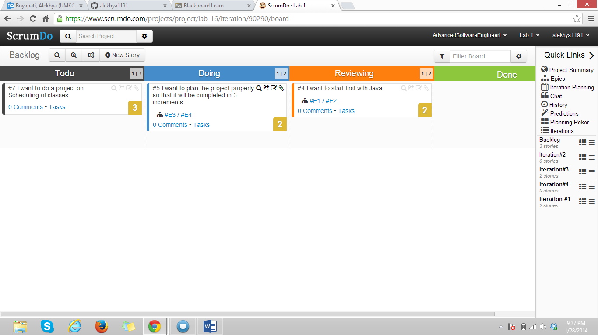

Step 18:

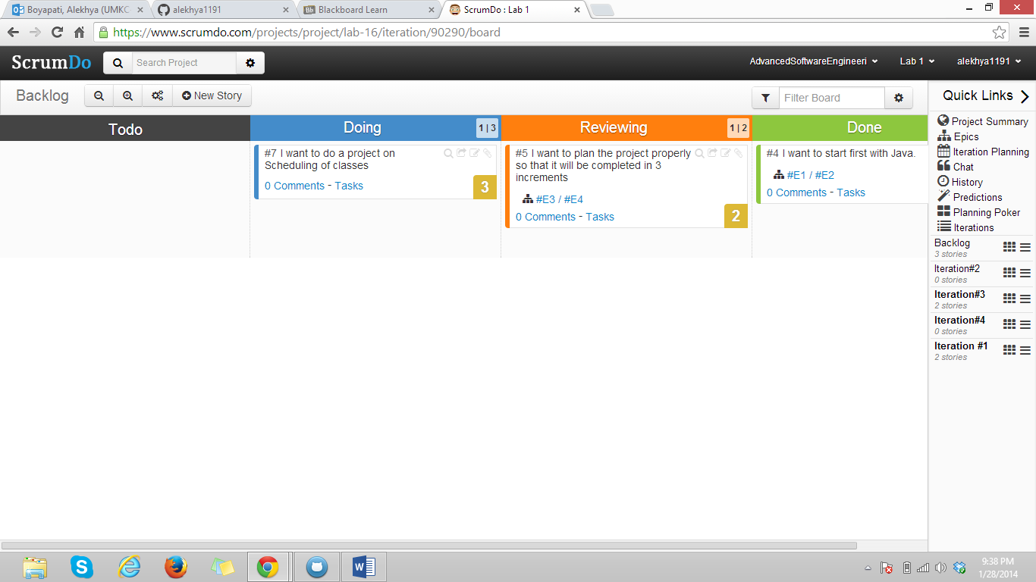

Step 19:

Formation of new team.

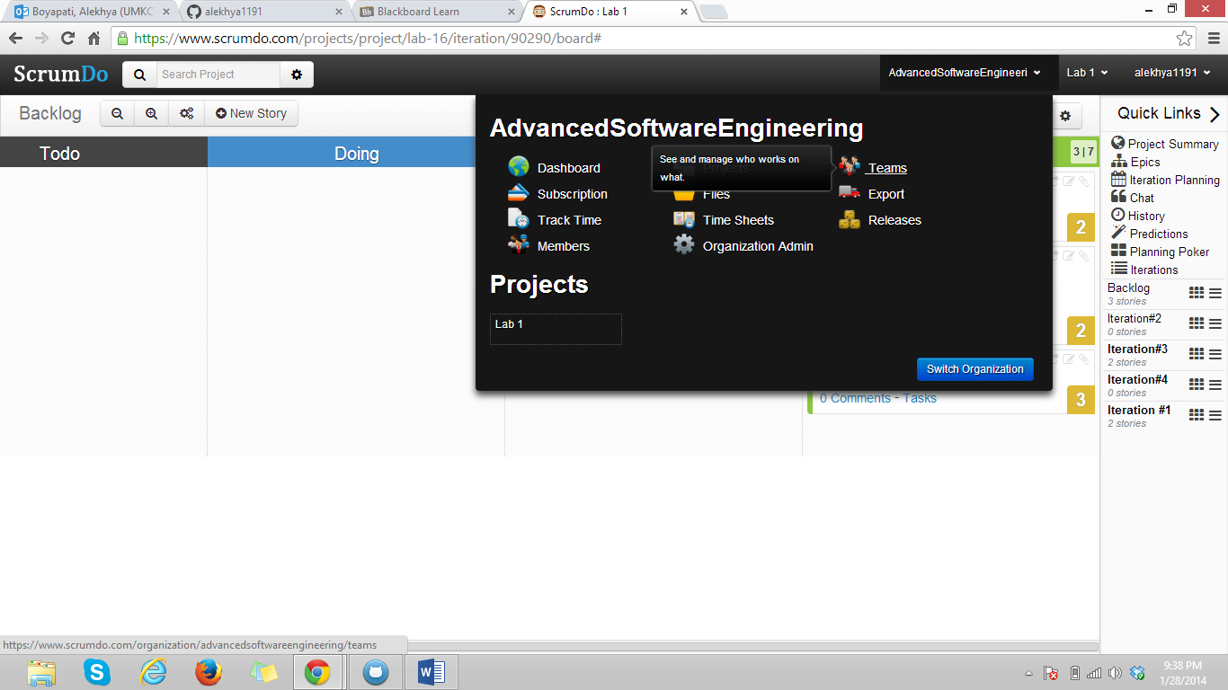

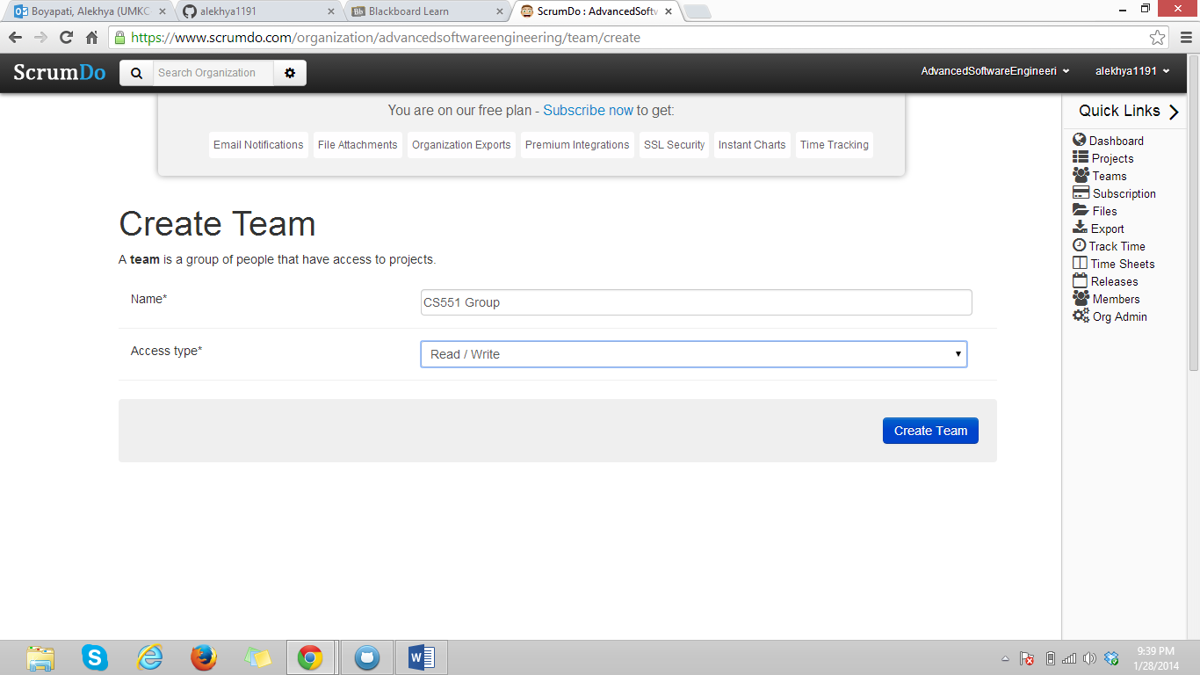

Step 20:

Inviting team member by using email.

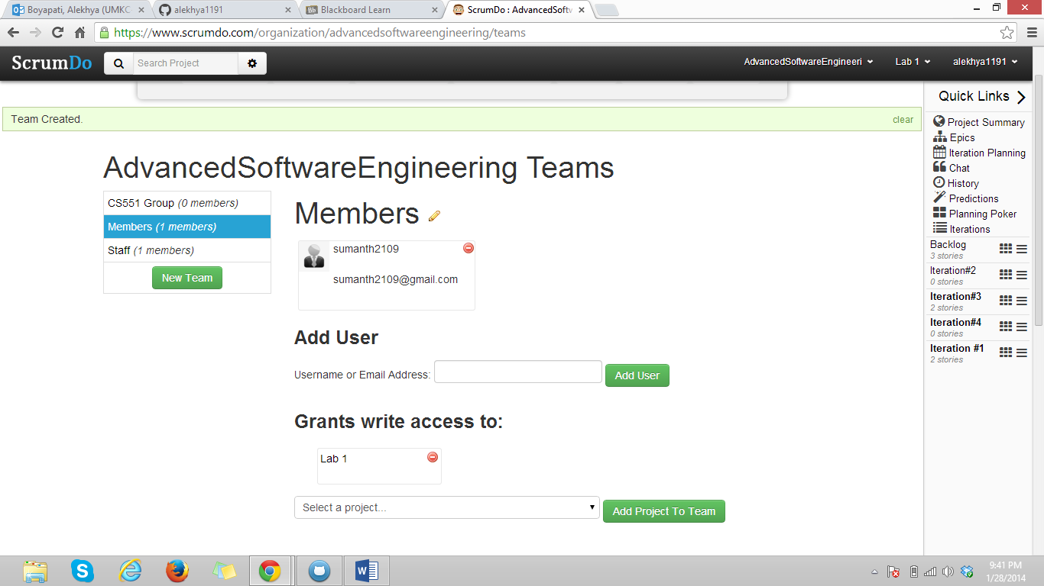

Visio report

I have designed UML class diagram for Home security system. This consists classes like SystemGUI, Loginbox, Controller, Sensors, different sensors like enter sensors, smoke and temperature sensors.

Here Smoke, enter and temperature sensors are four subclasses of class sensors. They inherit variables like sensorcode, sensorname and sensorstatus and setsensorthreshold() and getsensorthreshold are the operations inherited.

Step 1:

Open Visio 2013 and select basic diagram.

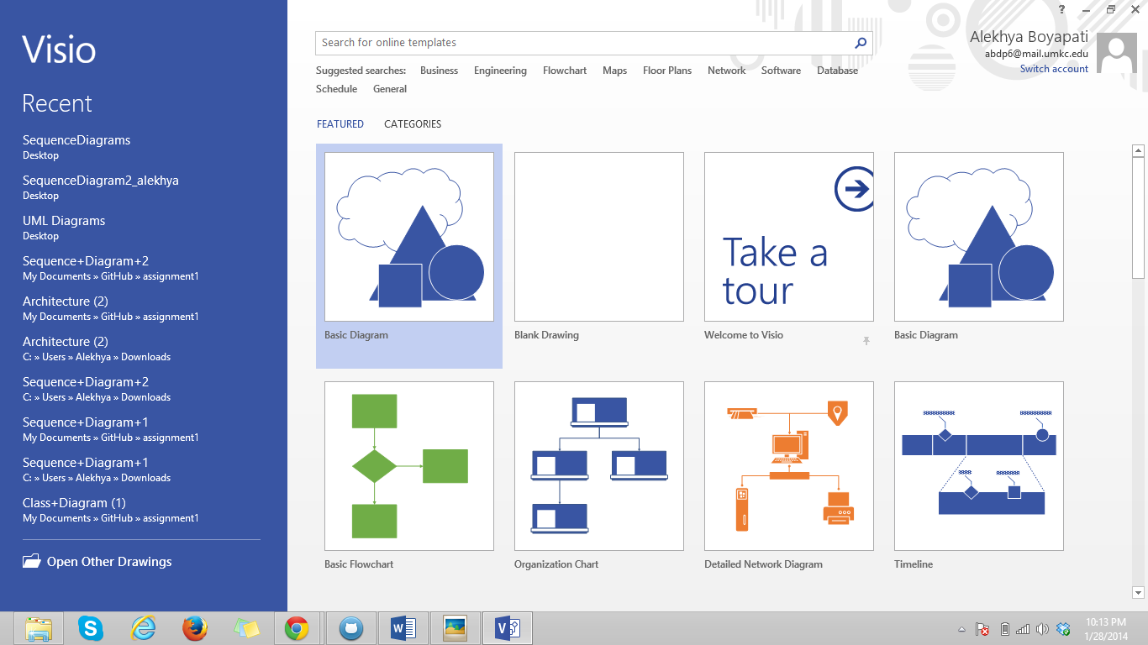

Step 2:

Search for UML.

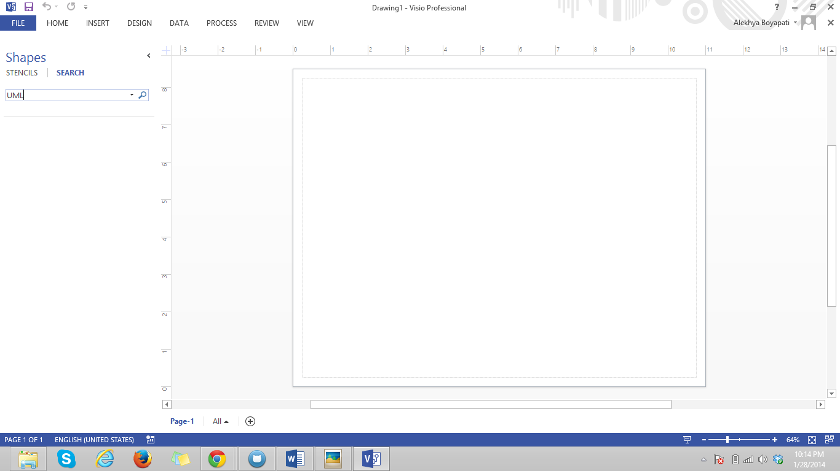

Step 3:

Search results.

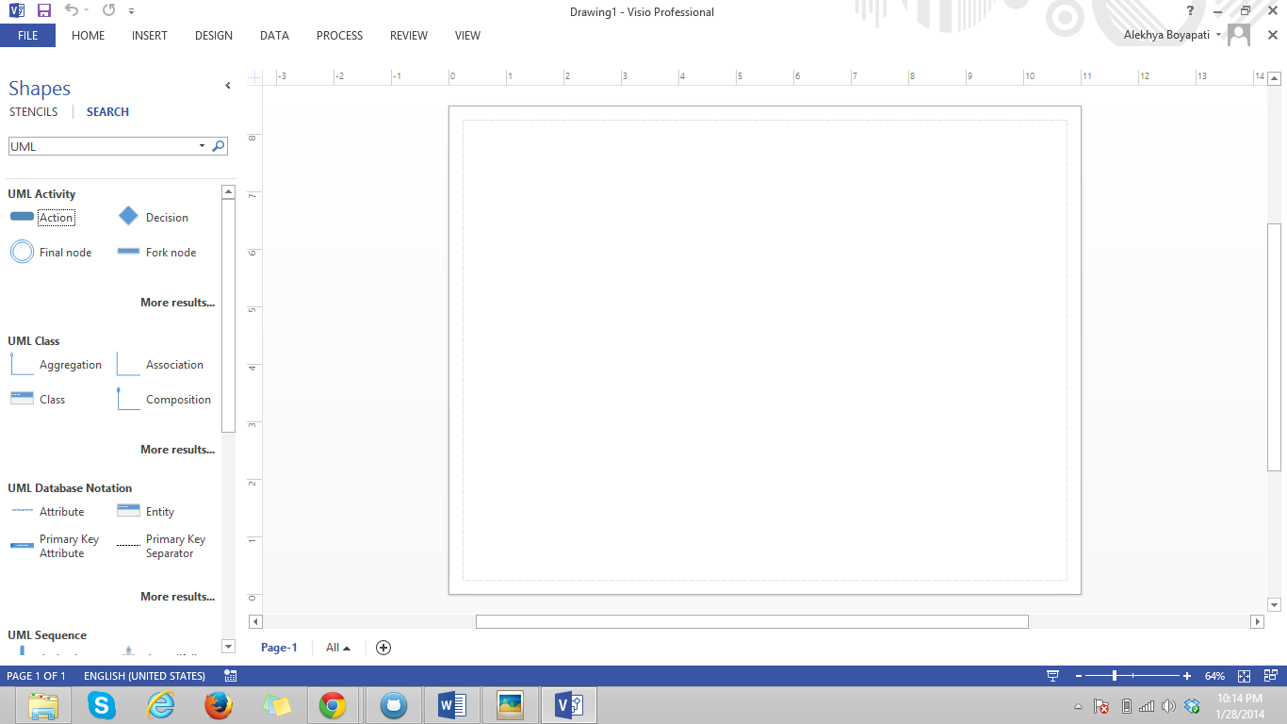

Step 4:

Drag the class and double click to change the class name and its attributes.

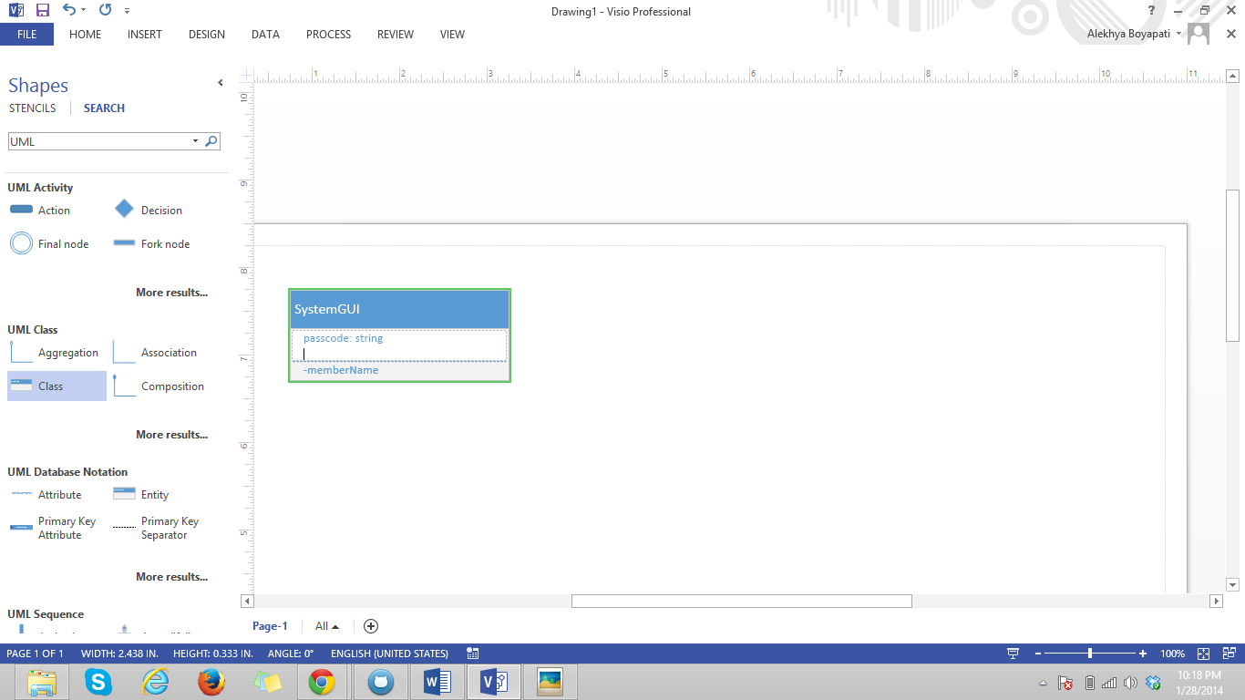

Step 5:

The UML class diagram for home security system is :

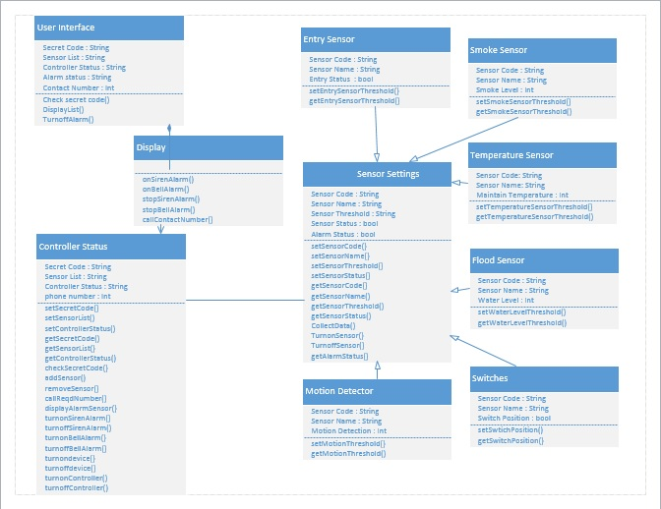

Step 6:

Next step is to draw UML sequence diagram for home security system. I have to draw two sequence diagram. One is sequence diagram for showing how the program is responding to alarm.

Step 7:

Drag and drop requires items like object lifeline, activation, self message in order to complete it.

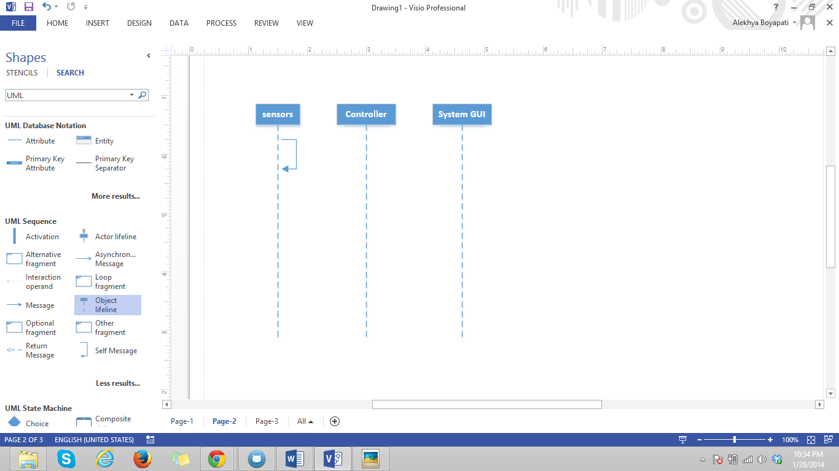

Step 8:

The completed sequence diagram is:

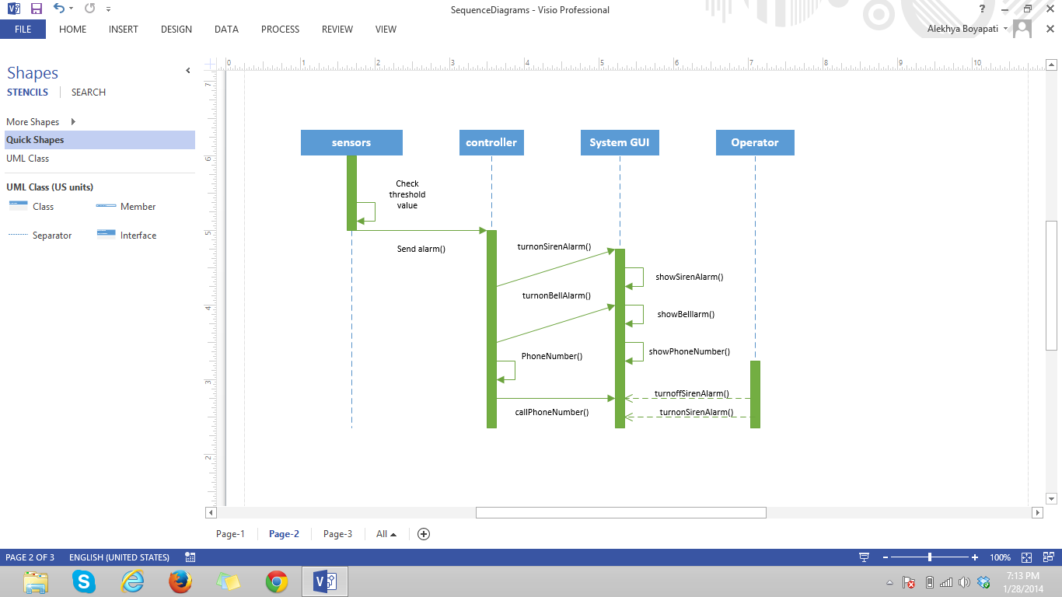

Step 9:

Another sequence diagram is to show how operator will be turning the system off. By dragging nd dropping the object line and required shapes e can complete it.

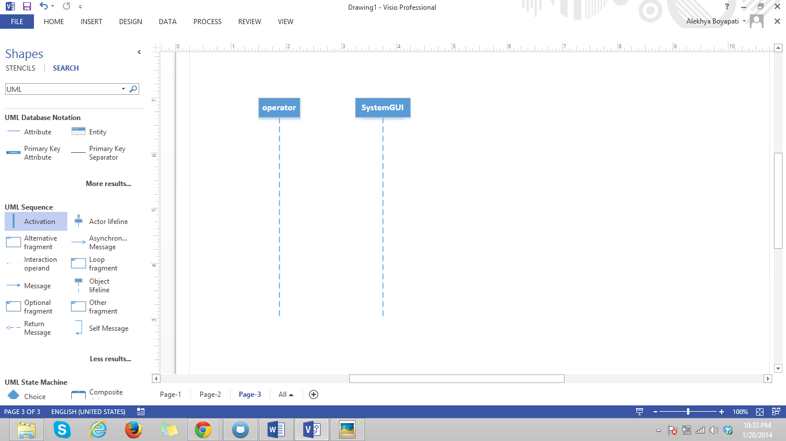

Step 10:

The completed sequence diagram is:

